Fractals with Orthogonal Poynomials

In mathematics, an orthogonal polynomial sequence is an infinite sequence of real polynomials
p0, p1,p2,…
of one variable x, in which each pn has degree n, and such that any two different polynomials in the sequence are orthogonal to each other under a particular version of the L2 inner product.
The field of orthogonal polynomials developed in the late 19th century from a study of continued fractions by P. L. Chebyshev and was pursued by A.A. Markov and T.J. Stieltjes and by a few other mathematicians. Since then, applications have been developed in many areas of mathematics and physics [1].
The theory of orthogonal polynomials includes many definitions of orthogonality. In abstract notation, is convenient to write
< p,q>=0
when the polynomials p(x) and q(x) are orthogonal. A sequence of orthogonal polynomials, then, is a sequence of polynomials
p0, p1, p2,…
such that pn has degree n and all distinct members of the sequence are orthogonal to each other.
We are not going to the details of orthogonal polynomials and how they are mathematically formulated. To implement them in Excel, all we requires is a Julia like template. We have done Julia Sets in a previous chapter. All we require here is the formula change in the iteration steps to operate on the Polynomials and adjust the coordinates for a good fractal generation.
Below are the orthogonal polynomial equations of various types that can we have used for fractal generation. Keep the below given figures for reference of the formula given along with the polynomials.

Bernoulli Polynomials
Workbooks: Fractal/Finished Works/Worksheets/Orthogonal Polynomials/Bernoulli/Unexpanded
We are generating Fractals from 7 orders of Bernoulli polynomial equations. We generate Julia like Fractals and the C values are shown in the figure below in the cells C13 and C14.
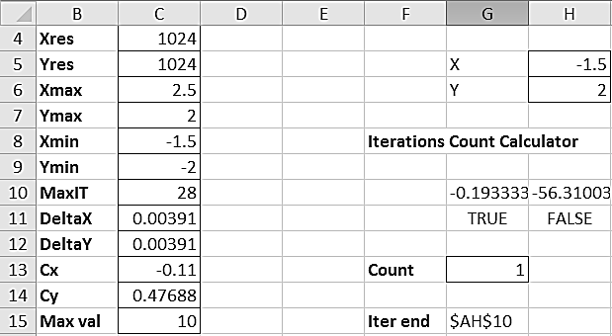
Write the formula for G10 and H10. Follow our normal procedure for Julia Set or Mandelbrot Set creation. We are not expanding each and every one of the equations, since there are about 42 equations in total which follow the same procedure in expansion, we are not including all the expanded files in the CD which comes along.
The Bernoulli equations for 7 orders are given below.
B₂ = z² – z + 1/6 + C
B₃ = z³ - 3z²/2 + z/2 + C
B₄ = z⁴ - 2z³ - z² - 1/30 + C
B₅ = z⁵ - 5z⁴/2 + 5z³/3 - z/6 + C
B₆ = z⁶ - 3z⁵ - 5z⁴/2 - z²/2 + 1/42 + C
B₇ = z⁷ - 7z⁶/2 + 7z⁵/2 - 7z³/6 + z/6 + C
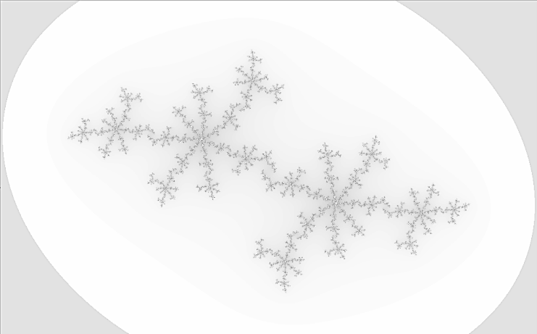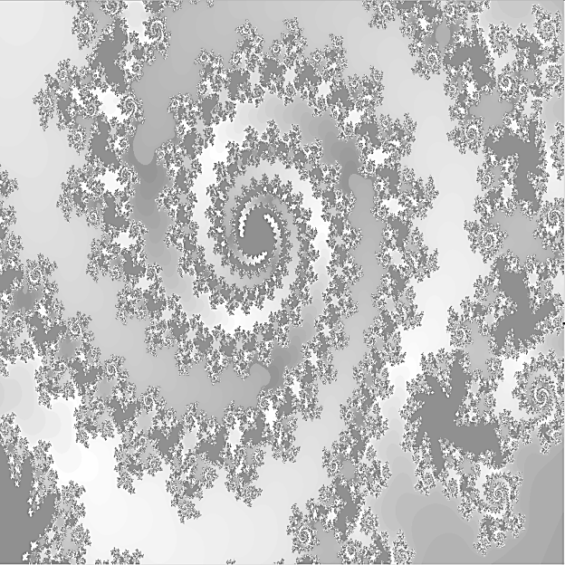
Chebyshev Polynomials
Chebyshev C polynomials
Workbooks: Fractal/Finished Works/Worksheets/Orthogonal Polynomials/Chebyshev C/Unexpanded
C₂ = z² – 2+C
C₃ = z³ - 3z + C
C₄ = z⁴ - 4z² +2 + C
C₅ = z⁵ - 5z³ + 5z + C
C₆ = z⁶ - 6z⁴ - 9z² - 2 + C
C₇ = z⁷ - 7z⁵ - 14z³ - 7z + C

Chebyshev S polynomials
Workbooks: Fractal/Finished Works/Worksheets/Orthogonal Polynomials/Chebyshev S/Unexpanded

S₂ = 2z² – 1 + C
S₃ = z³ - 2z + C
S₄ = z⁴ - 13z² + 1 + C
S₅ = z⁵ - 4z³ + 3z + C
S₆ = z⁶ - 5z⁴ - 6z² - 1 + C
S₇ = z⁷ - 6z⁵ - 10z³ - 4z + C
Chebyshev T polynomials
Workbooks: Fractal/Finished Works/Worksheets/Orthogonal Polynomials/Chebyshev T/Unexpanded

T₂ = 2z² – 1+C
T₃ = 4z³ - 3z + C
T₄ = 8z⁴ - 8z² +2 + C
T₅ = 16z⁵ - 20z³ + 5z + C
T₆ = 32z⁶ - 48z⁴ - 18z² - 1 + C
T₇ = 64z⁷ - 112z⁵ - 56z³ - 7z + C
Chebyshev U polynomials
Workbooks: Fractal/Finished Works/Worksheets/Orthogonal Polynomials/Chebyshev U/Unexpanded

U₂ = z² – 2 + C
U₃ = 8z³ - 4z + C
U₄ = 16z⁴ - 12z² +1 + C
U₅ = 32z⁵ - 32z³ + 6z + C
U₆ = 64z⁶ - 80z⁴ - 24z² - 1 + C
U₇ = 128z⁷ - 192z⁵ - 80z³ - 8z + C
Legendre Polynomials
Workbooks: Fractal/Finished Works/Worksheets/Orthogonal Polynomials/Legendre/Unexpanded

P₂ = 3z²/2 – 1/2+C
P₃ = 5z³/2 - 3z/2+ C
P₄ = 35z⁴/8 - 30z²/8 + 3/8 + C
P₅ = 63z⁵/8 - 70z³/8 + 15z/8 + C
P₆ = 231z⁶/16 - 315z⁴/16 - 105z²/16 – 5/16 + C
P₇ = 429z⁷/16 - 693z⁵/16 - 315z³/16 - 35z/16 + C
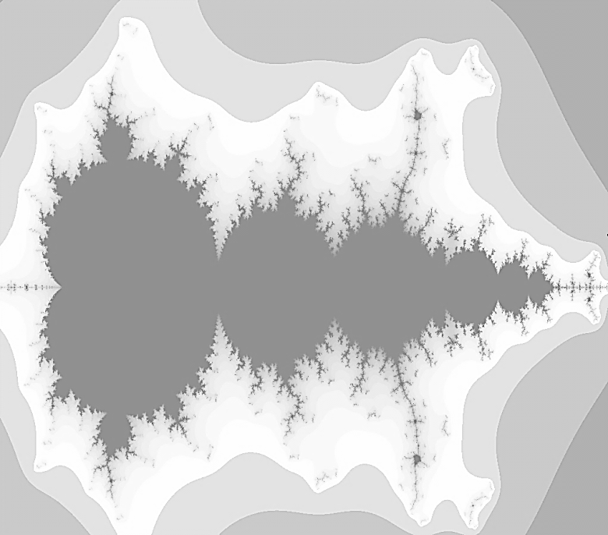
Laguerre Polynomials
Workbooks: Fractal/Finished Works/Worksheets/Orthogonal Polynomials/Laguerre/Unexpanded

L₂ = z²/2 - 2z + 1 + C
L₃ = -z³/6 + 3z²/2 - 3z + 1 + C
L₄ = z⁴/24 - 2z³/3 + 3z² - 4z + 1 + C
L₅ = -z⁵/120 + 5z⁴/24 - 10z³/6 - 5z² - 5z + 1 + C
L₆ = z⁶/720 + 20z⁵ + 5z⁴/8 - 10z³/3 + 15z²/2 - 6z + 1 + C
L₇ = -z⁷/5040 + 7z⁶/720 - 7z⁵/40 + 35z⁴/24 - 35z³/6 + 21z²/2 - 88z/9 - 1 + C
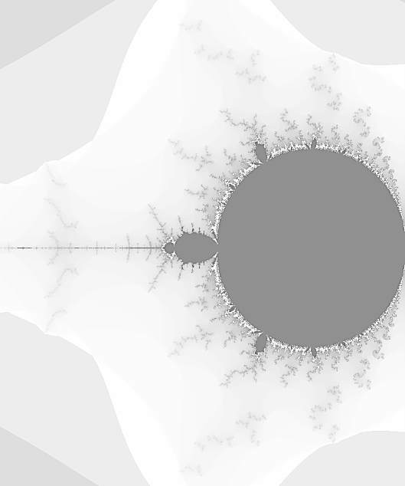
Hermite polynomials
Workbooks: Fractal/Finished Works/Worksheets/Orthogonal Polynomials/Hermite/Unexpanded

H₂ = 4z² – 2 + C
H₃ = 8z³ - 12z + C
H₄ = 16z⁴ - 48z² +12 + C
H₅ = 32z⁵ - 160z³ + 120z + C
H₆ = 64z⁶ - 480z⁴ - 720z² - 120 + C
H₇ = 128z⁷ - 1344z⁵ - 3360z³ - 1680z + C

It is a good idea to create a testing file for both Mandelbrot and Julia type with a resolution of 100x100 and make all the testing and adjustments there. It takes barely a minute for any fractal completion in a 100x100 resolution.
References
[1] http://en.wikipedia.org/wiki/Orthogonal_polynomials

